Black Lives Matter Week @ Seaton Elementary
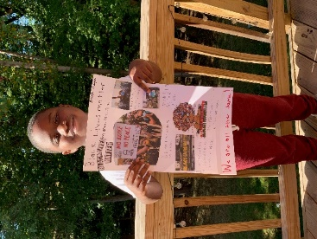
January 31st to February 4th
How to talk to young children about the Black Lives Matter Guiding Principles
By Laleña Garcia
As we think about discussing big ideas with little people, we consider age-appropriate language so that our students or children can grasp the concepts we’re introducing and incorporate these ideas and language into their own thinking and conversation. See more.

What’s happening at Seaton this week
Monday - Restorative Justice, Empathy, Loving Engagement

Tuesday - Diversity and Globalism

Wednesday - Trans-Affirming, Queer Affirming, and Collective Value

Thursday - Intergenerational, Black Families, Black Villages

Friday - Centering Black Women and Unapologetically Black

Literature – books highlighting African American and Afro Latinx culture
Early Childhood (Pre-K 3 and 4)
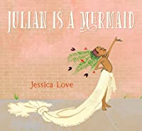Julian Is A Mermaid | 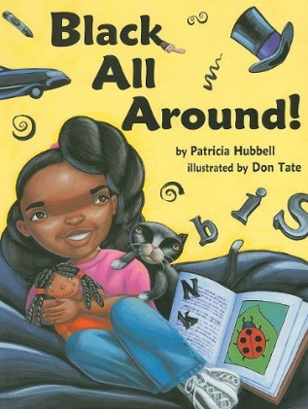Black All Around | 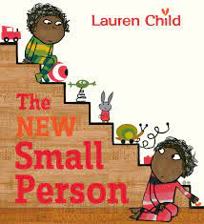The New Small Person | 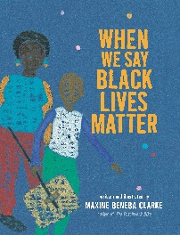  When we say Black Lives Matter
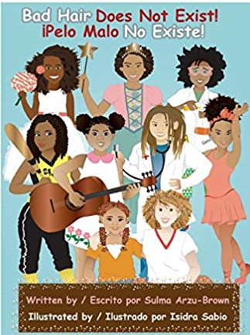  Bad Hair Does Not Exist  Pelo Malo No Exist | 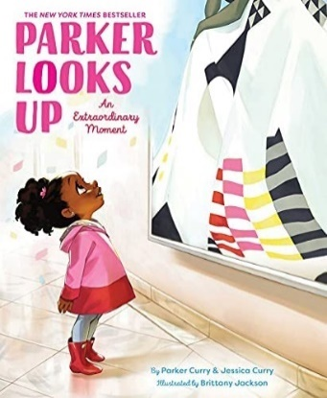Parker Looks Up | 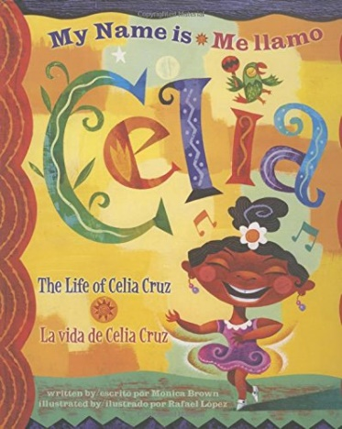  My Name is Celia  Me Llamo es Celia | Lessons to explore:  Teaching Consent: Centering Empathy, Diversity, and Loving Engagement in Early Childhood

Kindergarten -2nd grade
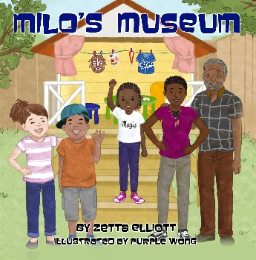Milo’s Museum | 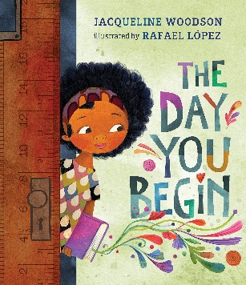They Day You Begin | 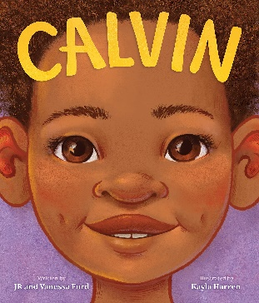  Calvin: Time to be me!  Lesson Plan | 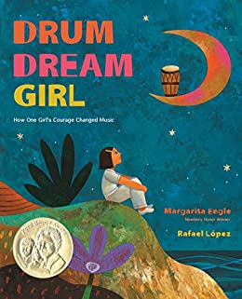Drum Dream Girl
Bad Hair Does Not Exist  Pelo Malo No Exist | 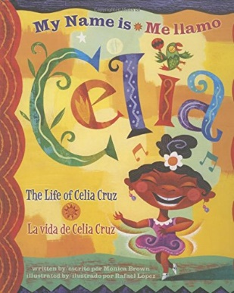My Name is Celia  Me Llamo es Celia | 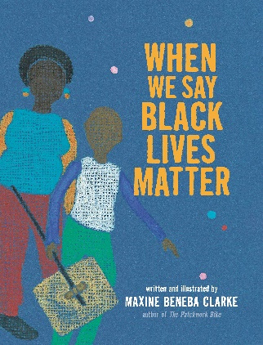  When we say Black Lives Matter | Lessons to explore:  Lesson Based on the Book ONE by Kathryn Otoshi  Art and Community Activism  Looking at Race and Racial Identity in Books  Different Colors of Beauty
3rd –5th grade
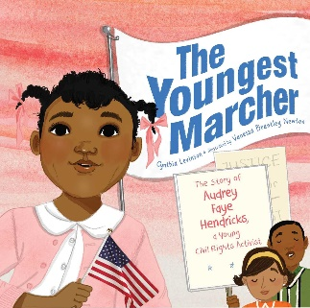The Youngest Marcher | 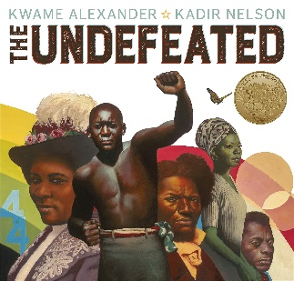The Undefeated | Bad Hair Does Not Exist  Pelo Malo No Exist | 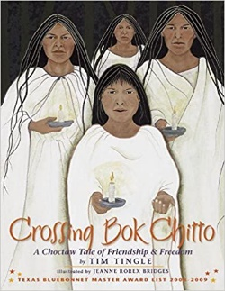Crossing Bok Chitto: A Choctaw Tale of Friendship and Freedom
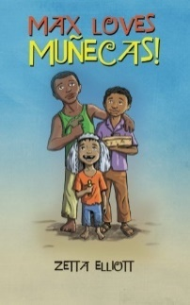  Max Loves Muñecas! (Independent read) | 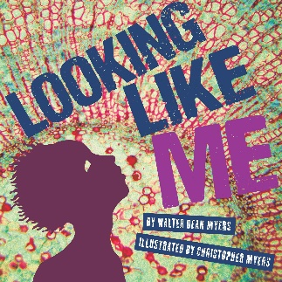Looking Like Me . | 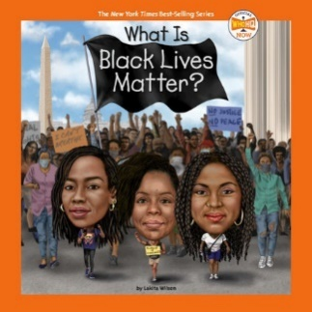  What is: Black Lives Matter? (Available at Seaton’s library) | Lessons Plans:  Different Colors of Beauty  Middle School Students Explain 13 Guiding Principles in American Sign Language  Looking at Race and Racial Identity in Books  Understanding Prejudice Through Paper Plate Portraits

Niña Bonita Bilingual Read A Loud by Mr. Brower
Watch this Bilingual Read aloud by Mr. Brower reads a story in English and Spanish about a white rabbit who falls in love with a very dark skin girl and longs to discover her secret for being so dark and pretty.
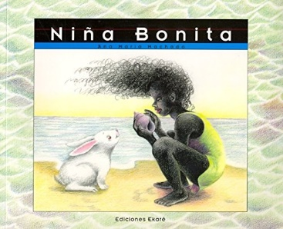
Activities
Black Lives Matter - coloring book
All Bodies Deserve – coloring book
Learn Black American Sign Language
Other resources

